Instruction of converting from PayPal sandbox environment to the living one
Date: 14 Feb 2011
Author: Ping Zou
Version: 0.1

PayPal developer account

Go to https://www.x.com/index.jspa
Signin with a valid PayPal account, must be verified business or premium PayPal account.

Submit an app to PayPal developer site for a Live App ID
Sign in to PayPal developer network.
My Apps -> Submit New App, filling the app info as the following figures.
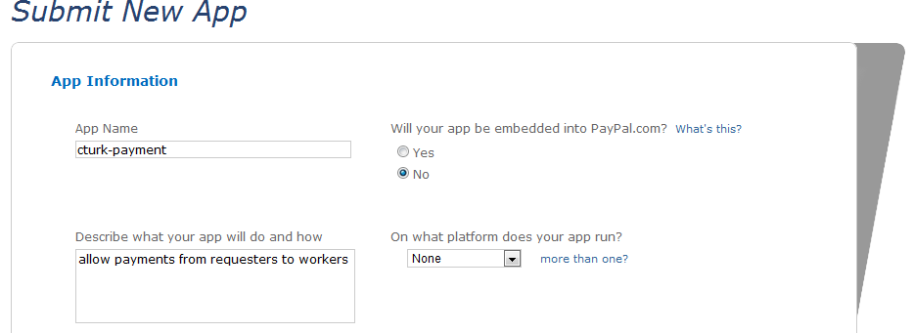
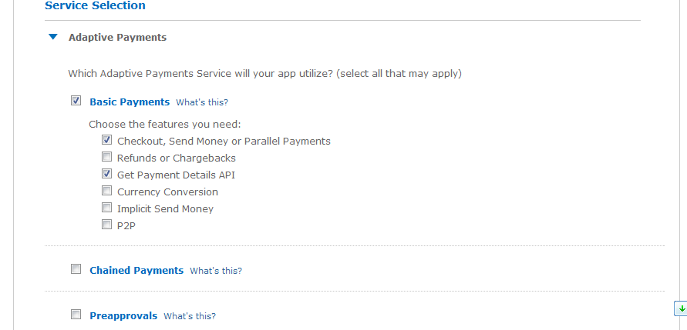
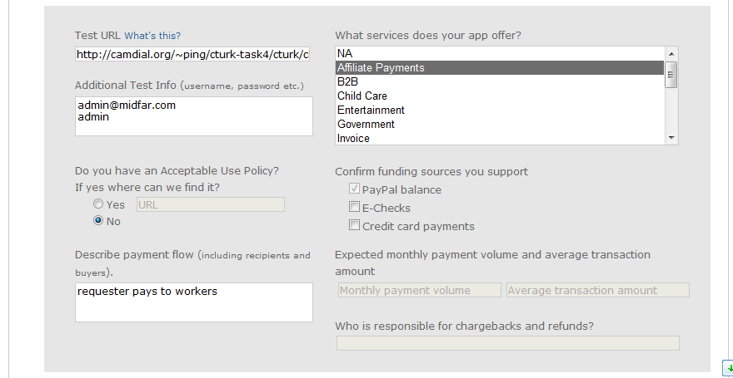
Leave the rest as default, there would be a valid app for CTurk now.
Then find the Live App ID from you're My App page.

Get PayPal API credentials
Log in PayPal site (https://www.paypal.com/) with the same PayPal account used as the PayPal developer account.
Profile -> API Access -> Request API credentials
Then find your API credentials including: API Username, API Password and Signature.

Update CTurk setting
Edit cturk/server/app_controller.php, edit the following variables to the living settings

var $PAYPAL_APPLICATION_ID = your Live App ID';
var $PAYPAL_API_EMAIL = 'your PayPal account ID';
var $PAYPAL_API_USERNAME = 'your API Username';
var $PAYPAL_API_PASSWORD = 'your API Password';
var $PAYPAL_API_SIGNATURE = 'your Signature';
var $PAYPAL_API_ENDPOINT = 'https://svcs.paypal.com/';
var $PAYPAL_REDIRECT_URL = 'https://www.paypal.com/webscr&cmd=';

